HEATHLAND AND BOG – SURVEY AND ASSESSMENT
Supporting notes for training course

Dry heaths
Dry heaths typically occur on free-draining acidic soils of generally low nutrient content. Ericaceous dwarf-shrubs dominate the vegetation. The most common is Heather or Ling (Calluna vulgaris), often in combination with Gorse (Ulex spp.) or Bilberry (Vaccinium spp.) Other dwarf-shrubs can be important locally. Most, though not all dry heath, is semi-natural, being derived from woodland with a long history of grazing and burning.

Eleven NVC communities in Britain include forms of dry/humid lowland heathland:
H1 Calluna vulgaris–Festuca ovina heath
H2 Calluna vulgaris–Ulex minor heath
H3 Ulex minor–Agrostis curtisii heath
H4 Ulex gallii–Agrostis curtisii heath
H6 Erica vagans–Ulex europaeus heath
H7 Calluna vulgaris–Scilla verna heath
H8 Calluna vulgaris–Ulex gallii heath
H9 Calluna vulgaris–Deschampsia flexuosa heath
H10 Calluna vulgaris–Erica cinerea heath
H11 Calluna vulgaris–Carex arenaria (dune) heath
H12 Calluna vulgaris–Vaccinium myrtillus heath

Wet heaths
Wet heath usually occurs on acidic, nutrient-poor, shallow peat or sandy soils with impeded drainage. Mixtures of Cross-leaved heath (Erica tetralix), grasses, sedges and Sphagnum typically dominate the vegetation.

In the UK this vegetation includes forms of the following NVC types:
H3 Ulex minor–Agrostis curtisii heath (when it contains E. ciliaris)
H4 Ulex gallii–Agrostis curtisii heath (when it contains E. ciliaris)
H5 Erica vagans–Schoenus nigricans heath
M14 Schoenus nigricans–Narthecium ossifragum mire
M15 Scirpus cespitosus–Erica tetralix wet heath
M16 Erica tetralix–Sphagnum compactum wet heath
M21 Narthecium ossifragum–Sphagnum papillosum valley mire (with E. ciliaris)

Associated habitats
Wet and dry heathlands often form mosaics. Lowland heathlands may also be closely associated with other habitats, e.g. upland heathland, grassland, woodland, valley mire
U1 Festuca ovina–Agrostis capillaris–Rumex acetosella grassland
U2 Deschampsia flexuosa grassland
U3 Agrostis curtisii grassland
U4 Festuca ovina–Agrostis capillaris–Galium saxatile grassland
CG2 Festuca ovina–Avenula pratensis grassland
CG7 Festuca ovina–Hieracium pilosella–Thymus praecox/pulegioides grassland
CG9 Sesleria albicans–Galium sterneri grassland
M3 Eriophorum angustifolium bog pool community
M21 Narthecium ossifragum–Sphagnum papillosum valley mire

Survey Techniques

Phase I

Methodology
Map extent of communities and target note as much detail as possible, including dominant species, habitat conditions and presence of key indicator species.

Habitat types
Heath – vegetation dominated by heather, usually on well-drained acidic soils
- Dwarf Shrub Heath – heathers and small gorses greater than 25%
- Wet dwarf shrub heath – heather cover greater than 25%, plus Molinia and possibly Sphagnum
- Lichen/bryophyte heath – bryos/lichens greater than 30%
- Montane heath/dwarf herb – diverse group of higher altitude heathlands
- Dry heath/acid grassland mosaic – where these two habitats form an intimate mosaic. Note proportions of each
- Wet heath/acidic grassland mosaic – as above but wetter!

Bog - Sphagnum-rich vegetation with no input of water from surrounding land.
- Raised bog
- Wet modified bog
- Dry modified bog

Flush and spring – occur where there is moving water on sloping ground
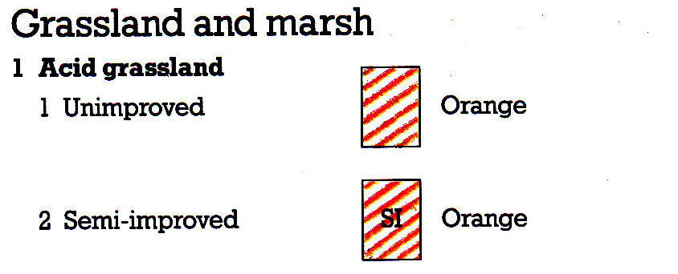
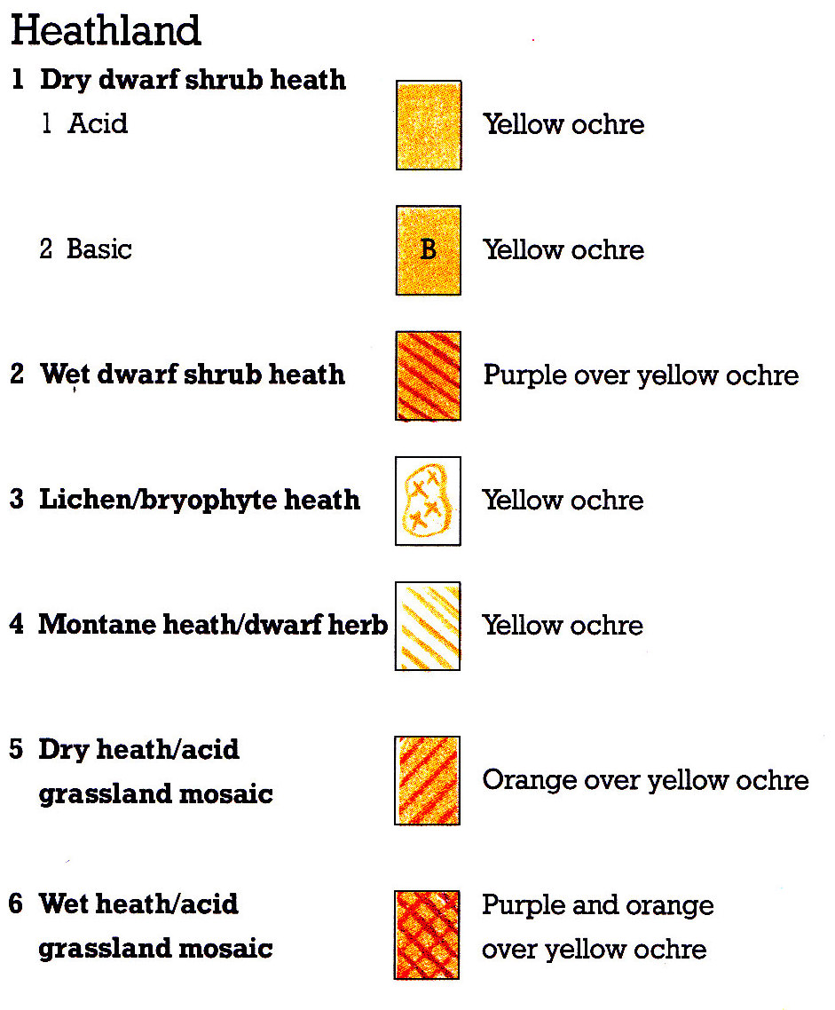
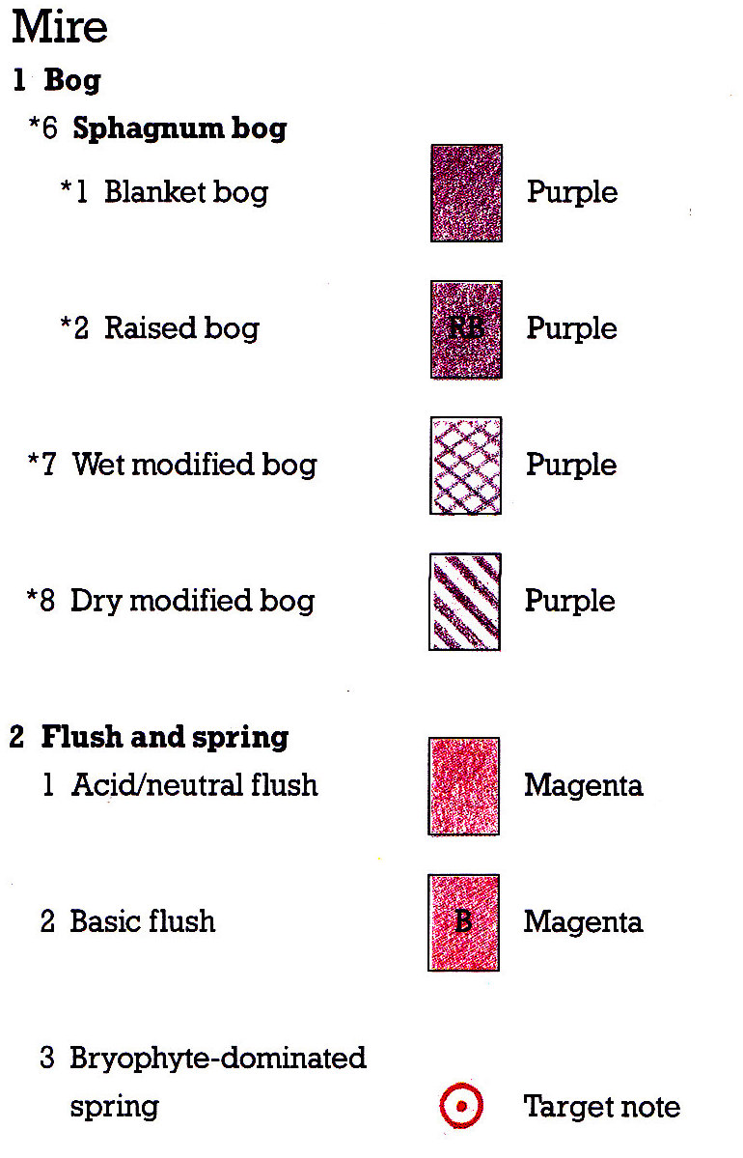
- Acid/neutral flush
- Basic flush
- Bryophyte-dominated spring

NVC

Methodology

- Map homogeneous stands
- Locate representative samples
- Establish boundaries or transition zones
- Consider using mosaics (these are where it is impossible to place a quadrat without encompassing towovegetation types)
- Decide size of plot
- Record cover values of all species present, either using % or DOMIN, depending on what sort of data analysis you are carrying out.
- 2x2m Dwarf-shrub heath
- 4x4m tall herb heaths
- Can be rectangular to better fit vegetation (e.g. on flushes)

Habitat types

Communities include those listed above plus several mire communities. (There are 38 mire and 22 heath communities, which take some learning to become familiar with). If you are not experienced, simply sample and map homogeneous stands then analyse and add community details later. Be prepared to re-visit sites once analysis is complete!

An excellent guide can be found here; http://jncc.defra.gov.uk/PDF/Mires_Heaths.pdf
or in the British Plant Communities books.

Analysis

Habitat can be keyed out in British Plant Communities. There are also two excellent free online tools for data analysis, which can be downloaded from the CEH website
MAVIS - http://bit.ly/2cpNjOr
TABLEFIT - http://bit.ly/2cA716b

Other factors to record

- Vegetation height (using drop disc)
- Heather health (pioneer, building, mature, degenerate, dead)
- Negative indicator species (invasive non-native, Bracken, gorse, trees, high nutrient species (e.g. Nettle, Ragwort, Thistle, Willowherb and coarse grasses)
- Physical degradation, such as erosion gullies, burning, bare ground

BOG AND HEATH SPECIES LIST (New Forest)
Forbs |  |  |  |  |  | Graminoids
Anagallis tenella |  |  | Bog Pimpernel |  |  | Agrostis capillaris | Common Bent
Bellis perennis |  |  | Daisy |  |  | Agrostis stolonifera | Creeping Bent
Calluna vulgaris |  |  | Heather |  |  | Aira praecox | Early Hair-grass
Chamaemelum nobile |  |  | Chamomile |  |  | Anthoxanthum odoratum | Sweet-vernal Grass
Cirsium dissectum |  |  | Meadow Thistle |  |  | Carex demissa | Common Yellow-sedge
Dactylorhiza praetermissa |  |  | Southern Marsh-orchid |  |  | Carex echinata | Star Sedge
Drosera intermedia |  |  | Oblong-leaved Sundew |  |  | Carex nigra | Common Sedge
Drosera rotundifolia |  |  | Round-leaved Sundew |  |  | Carex ovalis | Oval Sedge
Erica cinerea |  |  | Bell Heather |  |  | Carex panicea | Carnation Sedge
Erica tetralix |  |  | Cross-leaved Heath |  |  | Carex pilulifera | Pill Sedge
Euphrasia sp. |  |  | Eyebright |  |  | Danthonia decumbens | Heath Grass
Galium saxatile |  |  | Heath Bedstraw |  |  | Eleocharis multicaulis | Many-stemmed Spike-rush
Hydrocotyle vulgaris |  |  | Marsh Pennywort |  |  | Eleogiton fluitans | Floating Club-rush
Hypericum elodes |  |  | Marsh St John's-wort |  |  | Eriophorum angustifolium | Common Cotton-grass
Hypochaeris radicata |  |  | Cat's-ear |  |  | Festuca ovina | Red Fescue
Leontodon hispidus |  |  | Rough Hawkbit |  |  | Festuca rubra | Sheep's Fescue
Leontodon saxatilis |  |  | Lesser Hawkbit |  |  | Glyceria fluitans | Floating Sweet-grass
Lotus corniculatus |  |  | Common Bird's-foot-trefoil |  |  | Juncus acutiflorus | Sharp-flowered Rush
Lotus pedunculatus |  |  | Greater Bird's-foot Trefoil |  |  | Juncus articulatus | Jointed Rush
Myrica gale |  |  | Bog Myrtle |  |  | Juncus bufonius | Toad Rush
Narthecium ossifragum |  |  | Bog Asphodel |  |  | Juncus bulbosus | Bulbous Rush
Ornithopus perpusillus |  |  | Bird's-foot |  |  | Juncus conglomeratus | Compact Rush
Pedicularis sylvatica |  |  | Lousewort |  |  | Juncus effusus | Soft Rush
Pilosella officinalis |  |  | Mouse-ear Hawkweed |  |  | Juncus squarrosus | Heath Rush
Pinguicula lusitanica |  |  | Pale Butterwort |  |  | Luzula campestris | Field Wood-rush
Plantago coronopus |  |  | Buck's-horn Plantain |  |  | Luzula multiflora | Heath Wood-rush
Plantago lanceolata |  |  | Ribwort Plantain |  |  | Luzula multiflora ssp. congesta | Dense-headed Heath Wood-rush
Potamogeton polygonifolius |  |  | Bog Pondweed |  |  | Molinia caerulea | Purple Moor-grass
Potentilla erecta |  |  | Tormentil |  |  | Nardus stricta | Mat-grass
Prunella vulgaris |  |  | Selfheal |  |  | Poa annua | Annual Meadow-grass
Radiola linoides |  |  | Allseed |  |  | Poa trivialis | Rough Meadow-grass
Ranunculus flammula |  |  | Lesser Spearwort |  |  | Trichophorum cespitosum | Deergrass
Sagina procumbens |  |  | Procumbent Pearlwort |  |  | Vulpia bromoides | Squirrel-tail's Fescue
Scorzonera autumnalis |  |  | Autumn Hawkbit
Scutellaria galericulata |  |  | Skullcap
Succisa pratensis |  |  | Devil's-bit Scabious
Veronica officinalis |  |  | Heath Speedwell

