WOODLAND SURVEY
TRAINING COURSE NOTES

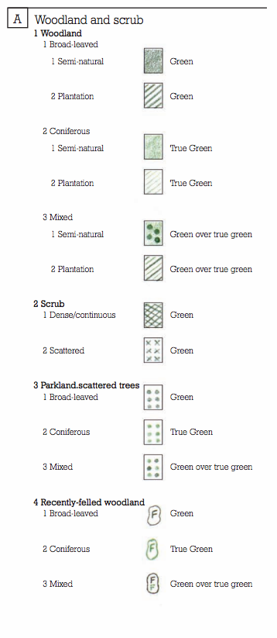
WOODLAND SURVEY TECHNIQUES

Two popular ways of surveying woods, Phase I and NVC (Phase II)

Phase I

Best way of mapping is to use aerial imagery followed by ground truthing

Woodland defined as ‘vegetation dominated by trees more than 5m high when mature, forming a distinct, although sometimes open, canopy’

Categories;
Broadleaved - less than 10% conifer
Coniferous - less than 10% broadleaved
Mixed - 10-90% of each

Large blocks should be mapped separately wherever possible

Species lists should include lists for canopy, understory and ground flora.

Distinction must be made between semi-natural and plantation. Most woods will fit into the semi-natural category, as this would include woodland with planted standards, mature coppice, under planted woods.

More info http://bit.ly/1QxCgu2

NVC

Methodology
Key to NVC is to map stands of homogenous vegetation, then take quadrats within each stand.

- Work out where the stands of homogenous vegetation are.
- Establish a canopy plot of 50x50m. Use a compass to orientate sides. For a permanent quadrat where orientation is vital measure out a diagonal of 70.71m and makes sides tight. Record all canopy species. Plot can be different dimensions to fit vegetation.
- Measure out a 10x10m square and record understory (scrub) species (diagonal 14.14m).
- Measure out a 4x4m square and record all species (diagonal 5.65m). If there is variation within the 50x50m plot then repeat these quadrats
- Combine all data and analyse

Habitat types (these are further divided into 72 sub-communities)

W1 Salix cinerea - Galium palustre woodland
W2 Salix cinerea - Betula pubescens - Phragmites australis woodland
W3 Salix pentandra - Carex rostrata woodland
W4 Betula pubescens - Molinia caerulea woodland
W5 Alnus glutinosa - Carex paniculata woodland
W6 Alnus glutinosa - Urtica dioica woodland
W7 Alnus glutinosa - Fraxinus excelsior - Lysimachia nemorum woodland
W8 Fraxinus excelsior - Acer campestre - Mercurialis perennis woodland
W9 Fraxinus excelsior - Sorbus aucuparia - Mercurialis perennis woodland
W10 Quercus robur - Pteridium aquilinum - Rubus fruticosus woodland
W11 Quercus petraea - Betula pubescens - Oxalis acetosella woodland
W12 Fagus sylvatica - Mercurialis perennis woodland
W13 Taxus baccata woodland
W14 Fagus sylvatica - Rubus fruticosus woodland
W15 Fagus sylvatica - Deschampsia flexuosa woodland
W16 Quercus spp. - Betula spp. - Deschampsia flexuosa woodland
W17 Quercus petraea - Betula pubescens - Dicranum majus woodland
W18 Pinus sylvestris - Hylocomium splendens woodland
W19 Juniperus communis ssp. communis - Oxalis acetosella woodland
W20 Salix lapponum - Luzula sylvatica scrub
W21 Crataegus monogyna - Hedera helix scrub
W22 Prunus spinosa - Rubus fruticosus scrub
W23 Ulex europaeus - Rubus fruticosus scrub
W24 Rubus fruticosus - Holcus lanatus underscrub
W25 Pteridium aquilinum - Rubus fruticosus underscrub

More info http://bit.ly/1QDzBoL

Typical Woodland Species

Forbs |  | Graminoids
Adoxa moschatellina | Moschatel | Anthoxanthum odoratum | Sweet Vernal Grass
Ajuga reptans | Bugle | Brachypodium sylvaticum | False Brome
Allium ursinum | Ramsons | Carex pendula | Pendulous Sedge
Anemone nemorosa | Wood Anenome | Dactylis glomerata | Cock's-foot
Angelica sylvestris | Wild Angelica | Deschampsia cespitosa | Tufted Hair-grass
Clematis vitalba | Traveller's-joy | Melica uniflora | Wood Melick
Conopodium majus | Pignut | Poa nemoralis | Wood Meadow-grass
Euphorbia amygdaloides | Wood Spurge | Poa pratensis | Smooth Meadow-grass
Ficaria verna ssp. fertilis | Lesser Celandine
Fragaria vesca | Wild Strawberry | Ferns
Galium aparine | Cleavers | Pteridium aquilinum | Bracken
Geranium robertianum | Herb-Robert | Dryopteris dilatata | Broad Buckler-fern
Geum urbanum | Wood Avens
Glechoma hederacea | Ground Ivy | Bryophytes
Hyacinthoides non-scripta | Bluebell | Atrichum undulatum | Common Smoothcap
Ilex aquifolium | Holly | Brachythecium rutabulum | Rough-stalked Feather-moss
Lamiastrum galeobdolon | Yellow Archangel | Campylopus atrovirens | Bristly Swan-neck Moss
Lonicera periclymenum | Honeysuckle | Cryphaea heteromalla | Lateral Cryphaea
Melampyrum pratense | Common Cow-wheat | Eurhynchium striatum | Common Striated Feather-moss
Mercurialis perennis | Dog's Mercury | Frullania dilatata | Dilated Scalewort
Neottia ovata | Common Twayblade | Homalothecium lutescens | Yellow Feather-moss
Orchis mascula | Early-purple Orchid | Hypnum cupressiforme | Cypress-leaved Plait-moss
Oxalis acetosella | Wood-sorrel | Isothecium myosuroides | Slender Mouse-tail Moss
Polygonatum multiflorum | Solomon's-seal | Kindbergia praelongum | Common Feather-moss
Potentilla sterilis | Barren Strawberry | Metzgeria furcata | Forked Veilwort
Sanicula europaea | Sanicle | Neckera crispa | Crisped Neckera
Stachys sylvatica | Hedge Woundwort | Ulota crispa | Crisped Pincushion
Stellaria holostea | Greater Stitchwort
Tamus communis | Black Bryony
Veronica chamaedrys | Germander Speedwell
Veronica montana | Wood Speedwell
Vicia sativa | Common Vetch
Viola riviniana | Common Dog-violet
Trees and shrubs
Corylus avellana | Hazel
Crataegus monogyna | Hawthorn
Cornus sanguinea | Dogwood
Ilex aquifolium | Holly
Quercus robur | Pedunculate Oak
Ruscus aculeatus | Butcher's-broom

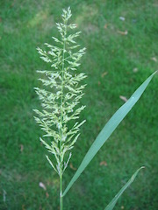
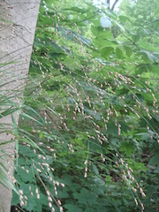
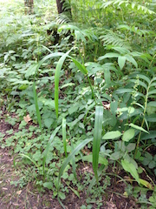
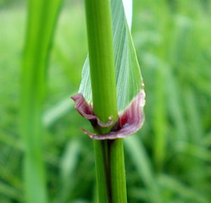
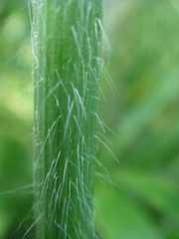
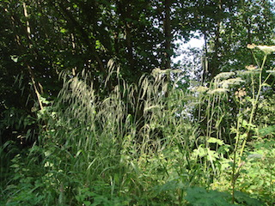
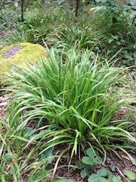
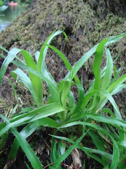
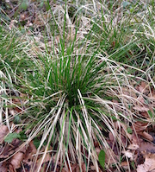
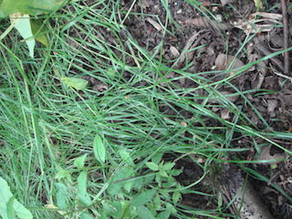
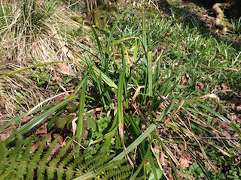
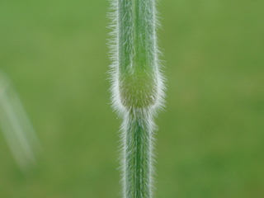
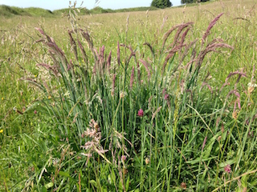
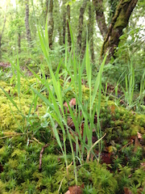
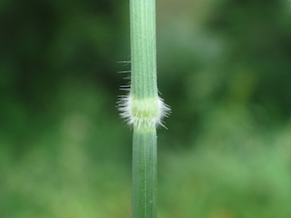
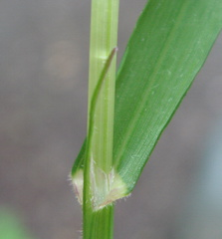
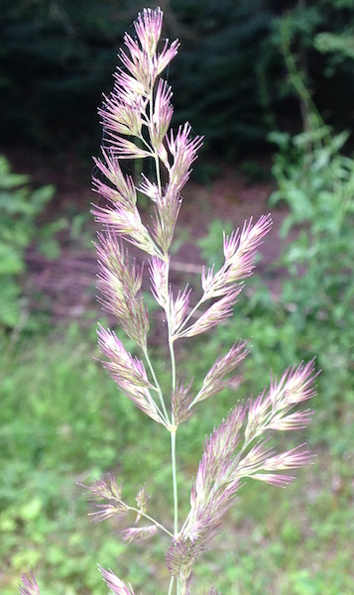
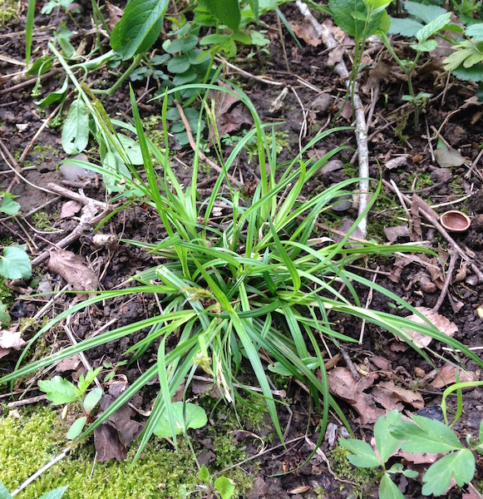
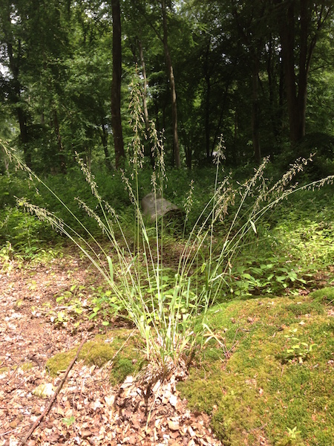
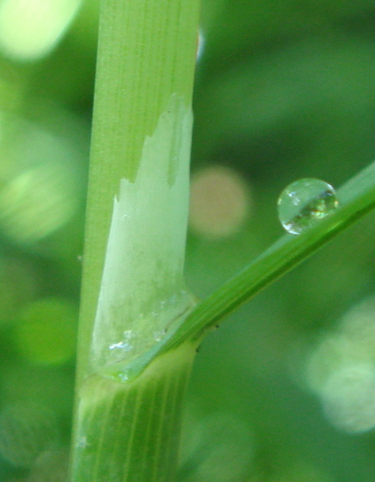
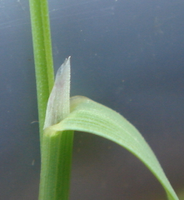
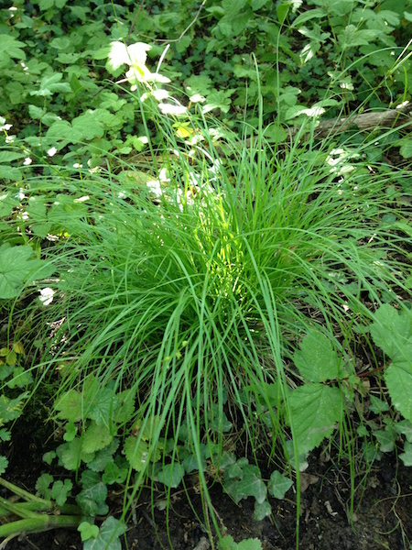
Luzula forsterii (narrower basal leaves, flowers droop to one side)

Calamagrostis epigejos
(Bulky tussocks, leaves with sharp serrated edges and reed-like flowers)

Poa nemoralis (narrow leaves craped on ground, tramlines visible with lens)

Deschampsia cespitosa (tough harshly toothed leaves)

Agrostis stolonifera
(Occasionally creeping, spearlike leaves and ragged ligule)

Milium effusum
(Tall grass with large delicate panicles resembling Millet)

Melica uniflora
(Attractive nodding heads, looking like rice. Top of sheath formed into single bristle)

Holcus mollis
(Pale green, soft leaves and hairy knees)

Bromopsis ramosa
(Bristly stems, long droopy branched heads)

Schedonorus giganteus (Giant Fescue)
(Huge, shiny broad leaves and purple auricles)

Luzula pilosa
(stiff stalks with flowers radiating in all directions)

Luzula sylvatica (tough, broad waxy leaves forming mats)

Carex remota (fine leaves, spread out spikelets and bract longer than stem)
Carex sylvatica (pale leaves, smaller version of pendula)

Carex pendula (large, fibrous leaves and drooping heads)

Sedge (tussock forming)
Normal looking grass
Drooping tussocky grass
Erect dark green tussocky grass
Narrow shiny prostrate grass
Large erect clumps
Hairy leaves, nut-like fruits
Holcus lanatus
(Pale grey-green, soft leaves and stripy pyjamas)
WOODLAND

